Traditional vs Agile Model

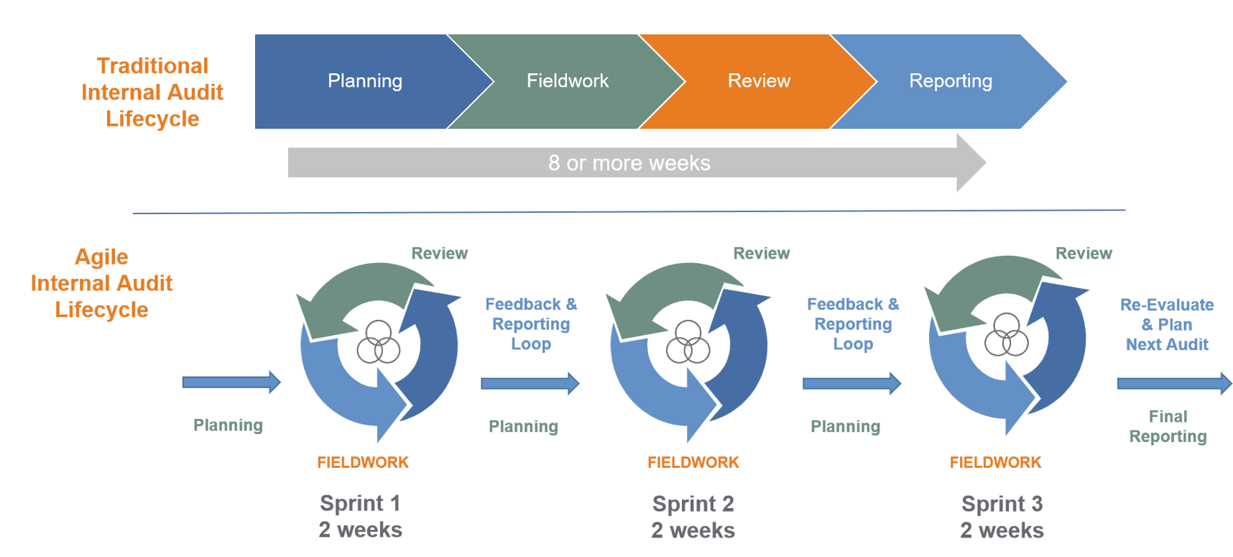

Traditional Waterfall Model

The Waterfall model is a linear sequential approach to software development, where each phase of the development process must be completed before moving on to the next. The phases include:

1. Requirements gathering: In this phase, the requirements are gathered from stakeholders and documented.
2. Design: In this phase, the requirements are used to design the software architecture, data models, and user interface.
3. Implementation: In this phase, the software is developed and tested.
4. Testing: In this phase, the software is tested to ensure that it meets the requirements and is free of errors.
5. Deployment: In this phase, the software is deployed to the production environment.
6. Maintenance: In this phase, the software is maintained and updated as needed.

One of the main advantages of the Waterfall model is that it provides a clear structure and allows for detailed planning and documentation.

However, it can be inflexible, as changes made in one phase may require starting over in previous phases.

Here's an example of how the Waterfall model might be used in practice:

Example:

A company wants to develop a new software product. They start by gathering requirements from stakeholders, documenting them in a detailed requirements document. Next, they move on to the design phase, where they use the requirements to design the software architecture, data models, and user interface.

They then move on to the implementation phase, where they develop and test the software. Once the software is developed, they move on to the testing phase, where they test the software to ensure that it meets the requirements and is free of errors.

Once the testing is complete, they deploy the software to the production environment, and finally move on to the maintenance phase, where they maintain and update the software as needed.

Agile Methodology

Agile methodology is an iterative and incremental approach to software development, where working software is delivered in small, incremental chunks. The Agile manifesto values:

Individuals and interactions over processes and tools

Working software over comprehensive documentation

Customer collaboration over contract negotiation

Responding to change over following a plan

The Agile development process includes the following phases:

1. Sprint planning: In this phase, the team plans what they will deliver in the upcoming sprint, which typically lasts for 2-4 weeks.
2. Sprint execution: In this phase, the team develops and tests the software, focusing on delivering working software in small, incremental chunks.
3. Sprint review: In this phase, the team demonstrates the software to stakeholders and collects feedback.
4. Sprint retrospective: In this phase, the team reflects on what worked well and what could be improved in the previous sprint.

One of the main advantages of Agile methodology is that it provides flexibility and adaptability, allowing for changes to be made throughout the development process.

However, it can be challenging to manage and requires a high level of collaboration and communication. Here's an example of how Agile methodology might be used in practice:

Example: A company wants to develop a new mobile app. They start by holding a sprint planning meeting, where the team plans what they will deliver in the upcoming sprint. They then move on to the sprint execution phase, where they develop and test the software in small, incremental chunks. At the end of the sprint, they hold a sprint review meeting, where they demonstrate the software to stakeholders and collect feedback. Finally, they hold a sprint retrospective meeting, where the team reflects on what worked well and what could be improved in the previous sprint, and use that feedback to plan the next sprint. They continue this process until the app is fully developed and ready for release.